FUJIFILM Europe GmbH

Balcke-Dürr-Allee 6,
40882 Ratingen,
Germany

Environmental Information & Data Sheet for Blue Angel
FUJIFILM Apeos C5570

Issued date: 22. December 2025

- General Information
Main functions | Copy, Print, Scan
Print & Copying speed (A4)* | Monochrome: 55 ppm | Colour: 55 ppm
Technology | Electrographic | Colour
Target user | This device is suited for the use in the professional and commercial/general office sectors.
Recycled paper | This device is suitable for processing recycled papers in accordance with the European standard of EN 12281:2002.
Duplex printing | This device is equipped with the automatic duplex printing function and the N-up function as the standard features.
Repairability of device | FUJIFILM or our partners offer the repair service and keep the spare parts (i.e. parts that can typically fail during the normal use of the product) for the period of 7 years from the end of its production in the factory.
Percentage of recycled plastic material | 5-10%
*Print speed is tested in accordance with ISO/IEC 24734.

- Collection system Information
FUJIFILM provides the collection system for used consumables and parts according to each market where FUJIFILM products are available. The target items include used toner cartridges, drum cartridges, waste toner containers, spare parts, batteries for FUJIFILM devices as well as those devices themselves. The collection system complies with the local legislations. Further information can be found in our web site https://office.fujifilmprint.eu/it/sustainability/.

- Instructions for handling the toner module
The toner cartridges included with the printer have been sealed to prevent toner dust from escaping. Never open the toner cartridge by force. If, despite all precautions, toner dust does escape, please make sure not to inhale it and avoid skin contact. Dirt on hands or clothing must be washed off immediately. Keep toner cartridges out of the reach from children.

- Chemical Emissions
Blue Angel indication for chemical emissions; New electronic devices generally emit volatile substances into the indoor air and that, therefore, the user should ensure more frequent air exchange in rooms where new equipment is set up or directly at the workplace, especially during the first days of use after its installation.
The testing was conducted according to the requirements of the Blue Angel ecolabel, using the consumables (types of toners) supplied and recommended by the manufacturer. As a result, the requirements were met.

- Power Consumptions
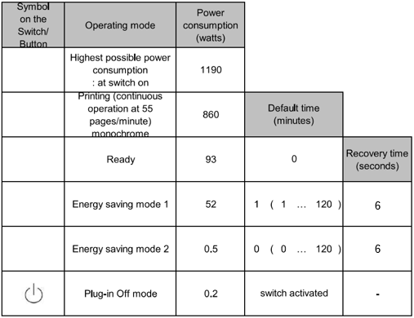

*Note
  - Default time: this is the duration that the device takes to switch to the energy saving mode after the completion of a printing operation.
  - Recovery time: this is the duration from the sleep mode to the ready state for printing operation.

This product is designed to save energy costs. The system automatically reduces energy consumption when not used for a period of time (1 minute). This mode is called Sleep Mode. From these states, the machine returns to standby printing in a short time (the return time listed above) when it receives a print or copy job. This allows you to save energy without limiting your productivity. With its return time, the system meets the high requirements of the Blue Angel, which attaches particular importance to user-friendliness in this respect.
The activation times for the sleep mode can be changed by the user in the range 1-120 minutes. However, if the activation times are increased, this leads to higher energy consumption and thus to higher electricity costs.
It is therefore recommended not to change the preset activation times.
When the main switch is actuated, there is still a low power consumption of max. 0.2 watts. Complete disconnection from the mains can be achieved by pulling the mains plug. Please observe the instructions in the operating instructions in order to prevent damage to the system and possible loss of data.
The device is designed so that it can be switched off at least twice a day.
For the standard use cycle according to the ENERGY STAR 3.0 standard, the following assumptions are made for a device like FUJIFILM Apeos C5570 : 32 print jobs per working day, each with 47 pages, single-sided using monochrome printing (1,504 pages/day).
The energy consumption for a week (7-day week with 5 working days of 8 hours each) in the standard use cycle according to ENERGY STAR 3.0, determined using printing test pattern A according to ISO 10561:1999, is 0.70 kWh/week.
This value was measured with the settings (delivery status) stated above.

- Noise Emissions
 | Monochrome mode | Colour mode
Declared Sound Power Level LWA,c | 67.6 dB(A) | 67.6 dB(A)
Tested in accordance with ISO 7779 and declared per ISO 9296.

- Environmental Labels
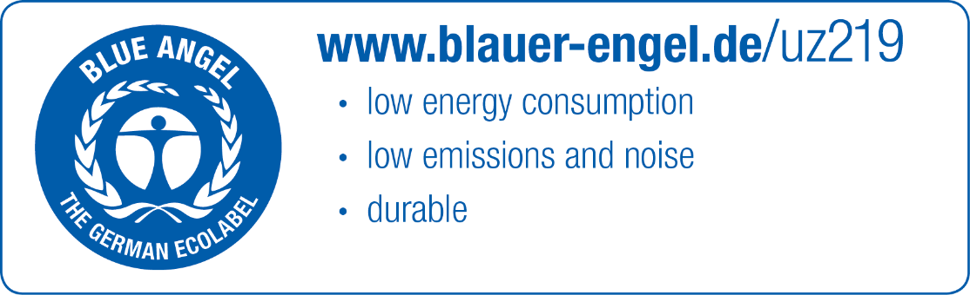
The device is awarded with the environmental label Blue Angel according to DE-UZ 219 for multifunction devices with the toner supplied and recommended by FUJIFILM. Further information regarding the Blue Angel can be seen at its web page (https://www.blauer-engel.de/en).

